[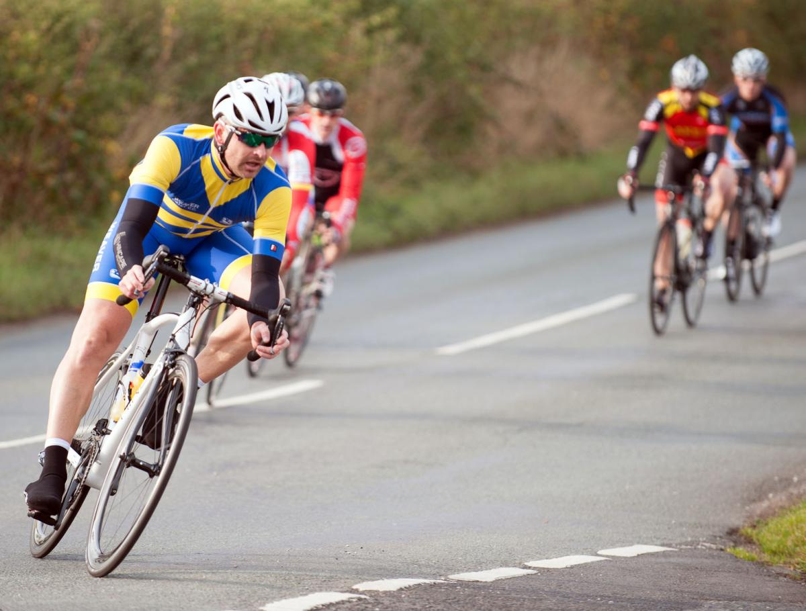](https://www.google.co.uk/url?sa=i&source=images&cd=&cad=rja&uact=8&ved=2ahUKEwia9auxj_7aAhUDuBQKHTTiBIkQjRx6BAgBEAU&url=http%3A%2F%2Fwww.northwichguardian.co.uk%2Fsport%2F13846228.CYCLING__Astles_first_Weaver_Valley_man_to_finish%2F&psig=AOvVaw3yHvq8T7LTuyE9bw2k33P8&ust=1526143932484732)